RSM 222 – Handout
CHAPTER 10 – VARIANCE ANALYSIS
Emerson Sports is a company that manufactures and sells ski helmets. One of their best-selling helmet is the EMX360 and this helmet is produced exclusively in a manufacturing plant in Squamish, BC. The manager has been pleased with the success of this helmet as the actual margins were much higher than initially anticipated. He would like to increase the production of this helmet to grow the brand but first, he asked you to perform a variance analysis of the Q4 performance.
For simplicity reasons, assume that the number of units sold = the number of units produced.
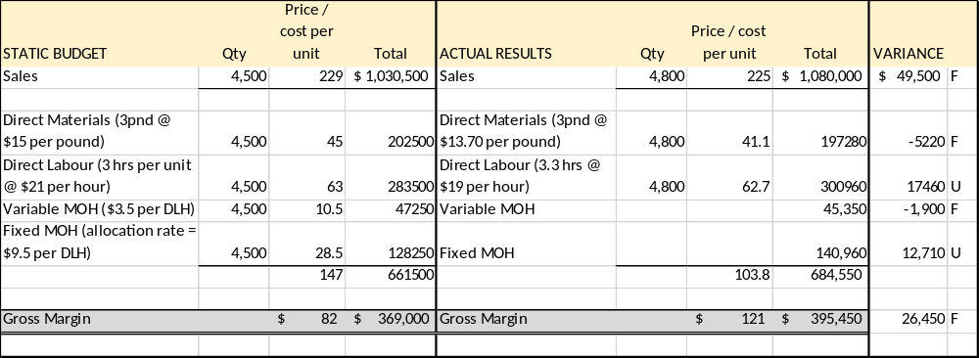

1 – Prepare a flexible Budget for Emerson
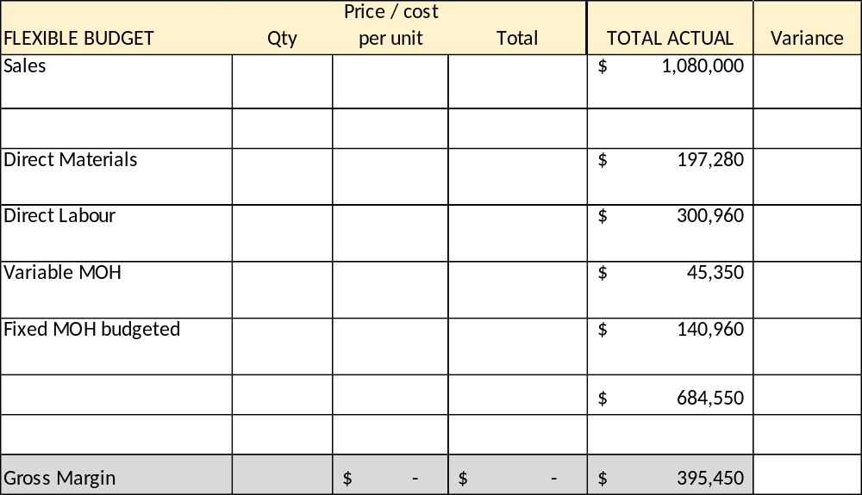

2 – Compute the Sales Price Variance and Sales Quantity Variance

3 – Compute the Materials Variance
- The Material Price Variance

- The Material Quantity Variance

4 – Compute the Labour Variances

- The Labour Rate Variance = (AR-SR)*AH

- The Labour Efficiency Variance = (AH-SH)*SR

5 – Compute the Overhead Variances

- Variable Overhead Spending Variance

- Variable Overhead Efficiency Variance

6 – Compute the fixed Overhead Variances

- Budget Variance = Actual Fixed OH – Flexible Budget Fixed OH

- Volume Variance = Fixed OH Rate * (Denominator hours – Standard Hours)

VARIANCE | FORMULA | DESCRIPTION
SALES VARIANCES
Sales price variance | (Actual Selling Price - Budgeted Selling Price ) * ASQ | Identifies the impact that is due to a change in the selling price of the item.
Sales Quantity/Volume Variance | (ASQ-BSQ)*BSP | Identifies the impact of the change in the volume of sales made vs. the budgeted level of sales. This helps management isolate the impact of the level of sales on their overall performance.
FLEXIBLE BUDGET VARIANCES
Materials Price Variance | (AP-SP)*AQ | Isolates the variance due to a change in price of the materials used in the production.
Materials Quantity Variance | (AQ-SQ)*SP | Isolates the variance due to a change in the quantity of the materials used in the production process. This helps management assess if they were efficient.
Labour Rate Variance | (AR - SR) * AH | Isolates the variance due to a change in the rate paid to employees for the production labour in the period.
Labour Efficiency Variance | (AH-SH)*SR | Isolates the variance due to number of hours worked. This will help management determine if the workers were efficient or not in the production process.
Variable OH Spending Variance | (AR-SR)*Actual units of the allocation basis | Identifies the difference between the actual variable OH cost incurred and the standard costs that should've been incurred for a given period.
Variable OH Variance | (Actual units of the allocation basis -Standard units of the allocation basis)*SR | Isolates the variance due to a change in the allocation base for the VOH. It presents the difference between the actual activity(DLH, DMH, units or other allocation base) and the standard activity allowed for a given period.
FIXED OVERHEAD VARIANCES
Fixed Overhead Budget Variance | Actual FixedOH - Flexible Budget OH | Presents the difference between the actual costs and what should've been spent based on the flexible budget.
Fixed Overhead Volume Variance | Fixed OH allocation Rate * (denominator hours - standard allowed allocation basis) | Measures the utilization of available plant facility. A favorable variance means the company operated at an activity level above the one planned for the period (and vice versa).

